



Data Entry & Inquiries
(PLANTA)
MODULE GUIDE

Table of Contents
1. Introduction 1
About this guide 1
2. Overview 2
3. Logging into Labor System 2
Contents Tree 3
4. DATA ENTRY 3
4.1 DATA ENTRY (NTE DATA ENTRY) 4
4.2 DATA ENTRY (MANNING) 5
5. UPLOADING & INQUIRIES 6
5.1 ADMINISTRATIVE CASE(S) 7
5.1.1 UPLOADING (N.T.E. & N.O.D.) 9
5.2 ENCODED N.T.E.’S 10
5.3 MANNING 11
5.2.1 UPLOADING (201 PDF FILE(S)) 13

- Introduction

About this guide

Data entry refers to user actions involving input of data to a computer. A type of clerical work that requires adding information to the system. This can be done through typing. Data entry refers to user actions involving input of data to a computer.
It also involves keeping databases up to date, ensuring the information is correct, and sorting data so it's easy to find. Sometimes, it even includes scanning documents.
Data entry aims to organize, update, and maintain data in its digital form, turning it into a usable format.
Without data entry, systems would be unable to store or process any information, making it impossible to carry out many digital tasks we rely on daily.
The objective of the data entry module guide is to assist the user in keying the Administrative cases into the Labor Systems (LS). The data entry procedure should be carefully followed according to the given instructions provided in this module guide.
The main reason for following these instructions is to avoid any discrepancies that may be encountered during the data entry process.
The Labor Systems (LS) user should have a good understanding of how the data are to be keyed. You should be familiar with the cases that is being keyed. It is important to ask the HR Labor Advisor if you have a problem with the Labor Systems (LS) or unsure about what action to take if an error occurs.
The main purpose of the Labor Systems (LS), is to have security of all data or files. The LS is to help use data collected, an automated system has been developed to store all information. This module guide was developed to explain this automated system — both what the system is and how to use it.
All units have access to the UI computer system. This system is also used by the Benefits Quality Control (BQC) Program, the UI Required Reporting (UIRR) system, and other UI projects. Data entry terminals will be available within each LS unit providing connectivity to the computer. The system is designed to allow access only to users having proper approval to prevent unauthorized use by other people on the UI computer.
The Labor Systems module is designed not only to simplify, but also to ensure the accuracy of the system that a user performs. There are a cross checking mechanisms that you can opt to ensure the accuracy of the cases details that the user enters into.

This guide is intended as an introduction to the Data Entry interface and its most commonly used features. The guide also provides a Workflow Example that includes:
  - All necessary steps from opening a Module, navigating through the Module and to login.
Step-by-step examples, showing you how to best use the features and navigation options.

Overview

An Overview introduces you to the computer equipment needed to run the Labor Systems (LS) software and the software necessary to support the LS system. Also described are the setups needed to allow LS users permission to enter data. Instructions are given for global procedures — such as cursor movement, menus, menu bars and the mouse — used in all data entry sessions regardless of the module involved. This includes what each screen looks like, how data is retrieved, updated, deleted etc. along with edits, error messages and help provided.
A menu is a list of options appearing on the monitor. It may be a list of programs or commands. This section describes different types of menus used in the LS system.

Data are an aggregate collection of information stored in the system. Data reside in files. The file structure is a logical way of storing data. Understanding this structure helps you to find the data you need.

Another component of software is the database system. A database system is a collection of data stored in the computer in a logical and consistent manner. Using this type of system allows the development of multiple applications using a common database. Also, the database system allows the computer to store data efficiently and yet allow easy retrieval.

Data Entry module is a system for the Mindbridge HR Labor user(s). This module is designed, primarily, to allow them to provide data requested by their HR Labor Advisor.
The HR Labor Advisor will publish an information request, with a number of Input Administrative cases for the Account user to complete. As part of the publication process for the information request, the HR Labor Advisor will provide the User ID & Password to use to log in the user(s) into Labor Systems (LS).
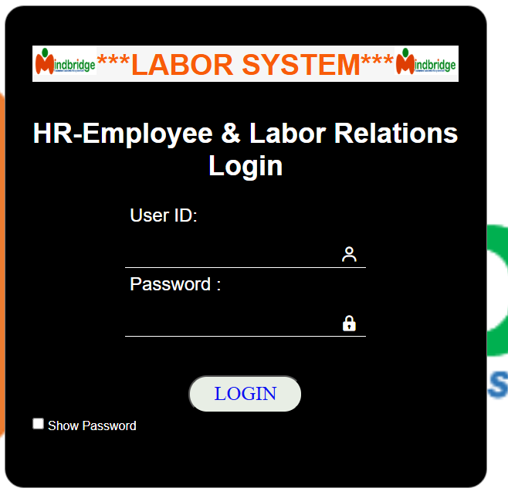
- Logging into Labor System

- Once the user(s) have received the User ID & Password details, click / type the given URL link provided and you will be taken to the log in page.

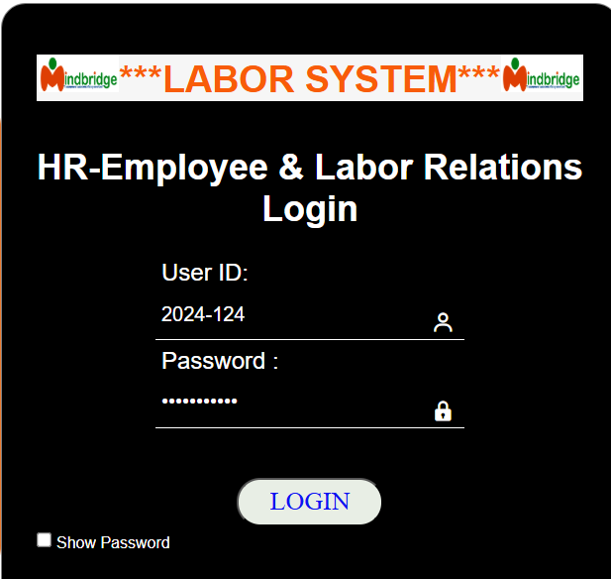
- On the Login page, type in your User ID and Password that you received and click the LOGIN button. After the successful login, the USER(s) will directly be lead to the Labor Systems page: Data Entry, Uploading & Inquiries.

Please note: You should follow your company security policy advice.

Contents Tree
When you open a Labor Systems (LS), a contents tree will be displayed to the left of the main screen.
The Contents tree will include a list of all Input statements that are available to you in this Data Entry Module and Reports & Inquiries.
The main window has the menu bar with the following options: DATA ENTRY, UPLOADING & INQUIRIES and LOGOUT.
These will be defined by the HR Labor Advisor, according to the information they require. The items listed in the Contents Tree will vary, since the HR Labor Advisor will select the appropriate content for each Data Entry Module that they create. Contents tree access assign only per user view and it will depend to the HR Labor Advisor.
To expand and collapse the hierarchy of the Labor Systems categories within the contents tree click on the Expand and Collapse icon respectively. Input statements at the bottom node in a hierarchy are indicated by the icon.

4. DATA ENTRY
* Data Entry Section - In the DATA ENTRY section, click inside a field to begin typing. Use the Tab key, Enter key, or mouse to navigate to the next field to complete missing information.
* Accessing Data Entry - To access the Data Entry section, go to the main window. Click on DATA ENTRY menu bar, then choose the criteria appears as shown below.The Labor Systems (LS) user(s) can view only the criteria base on their user LOGIN.

On selecting the “DATA ENTRY” option on the menu-bar of the main window, a pull-down menu is displayed the N.T.E DATA ENTRY. as shown in the window.
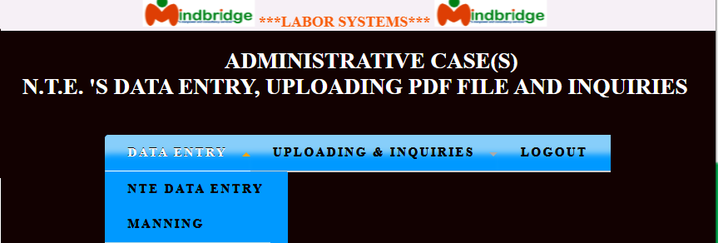

4.1 DATA ENTRY (NTE DATA ENTRY)
Toggle mouse/cursor to the DATA ENTRY
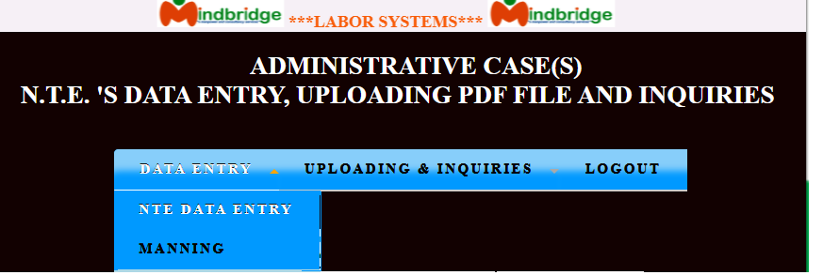
=> N.T.E DATA ENTRY

On selecting the “NTE DATA ENTRY” option, the Information window is displayed. Given below is a sample display of the ADMINISTRATIVE (CASE(S) N.T.E.’s DATA ENTRY control information window.
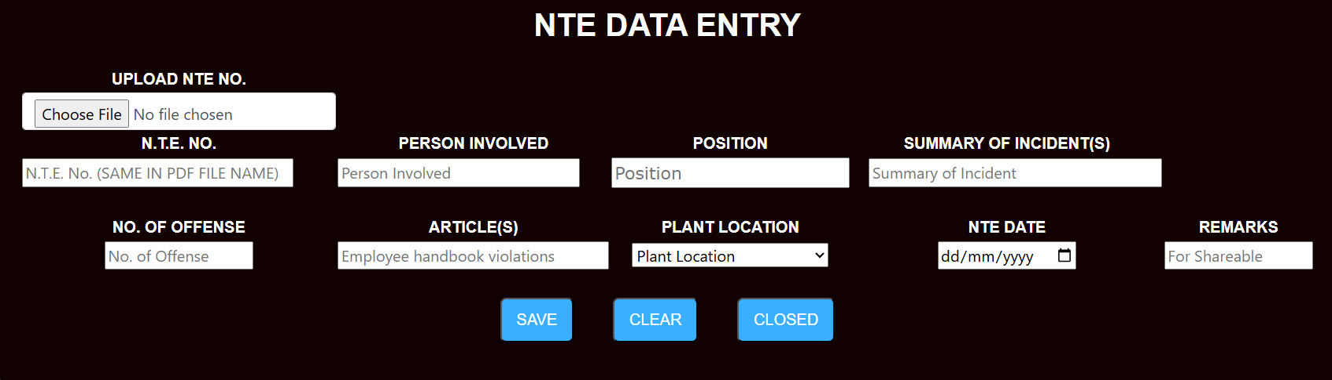
All data fields in the N.T.E DATA ENTRY must be filled. The user(s) must fill up all the necessary and required fields. All information are found on the submitted documents.
In “Remarks” field, type the word “Share or Shareable” only, if the case is shareable charges so that the entire case will go to the assign Labor Associate who handle the shareable cases.
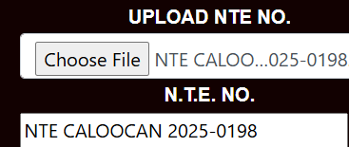
In uploading NTE image file, click “Choose FIle”, then, find the image you want to to upload.

Reminder: The file name of your image pdf must be the same as your NTE No.

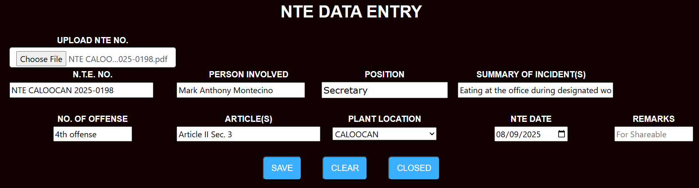
Always review the encoded data to ensure all data is correctly populated before finalizing, and saving. After ensuring all required fields are correctly completed, the data is saved by selecting the "SAVE" button.

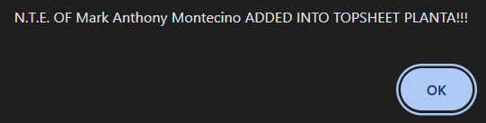
After the SAVE button is clicked, the pop up message will show like this and click OK to return to the NTE Data Entry screen afterwards.

4.2 DATA ENTRY (MANNING)
1. Toggle mouse to DATA ENTRY
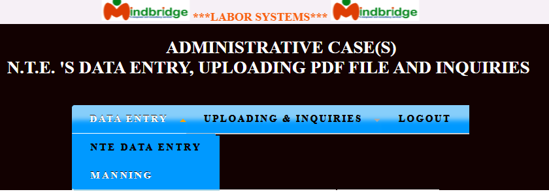
=> MANNING

On selecting the “MANNING” option, the Information window is displayed. Given below is a sample display of the MANNING DATA ENTRY control information window.

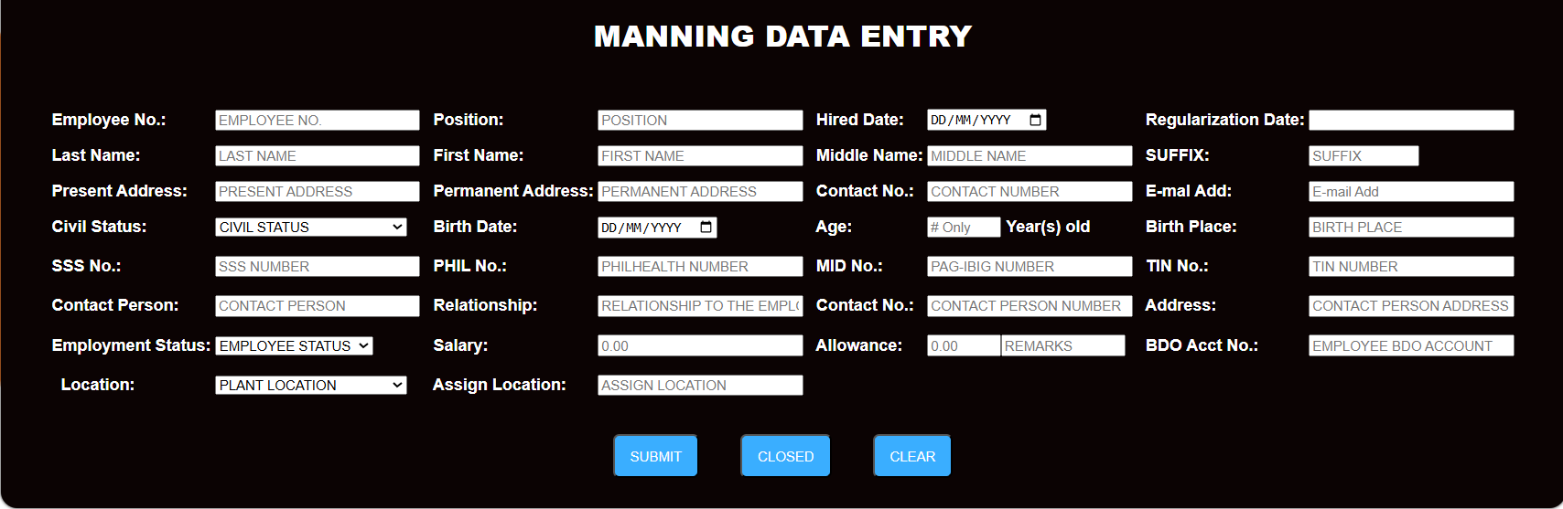
All data fields in the MANNING DATA ENTRY must be filled, except

Regularization Date (automatically display 180 days from the hired date) and Age (automatically computed from a birth date). The user(s) must fill up all the necessary and required fields. All information are found on the submitted documents. Always review the encoded data to ensure all data is correctly populated before finalizing, and saving. After ensuring all required fields are correctly completed, the data is saved by selecting the "SUBMIT" button.

5. UPLOADING & INQUIRIES

Uploading & Inquiries Section - The UPLOADING & INQUIRIES section allows the user to upload pdf file image and inquire the data or access details of the subject person involved / employee.
* Accessing Uploading & Inquiries - To access the UPLOADING & INQUIRIES section, go to the main window. Click on UPLOADING & INQUIRIES menu bar, then choose the criteria appears as shown below.
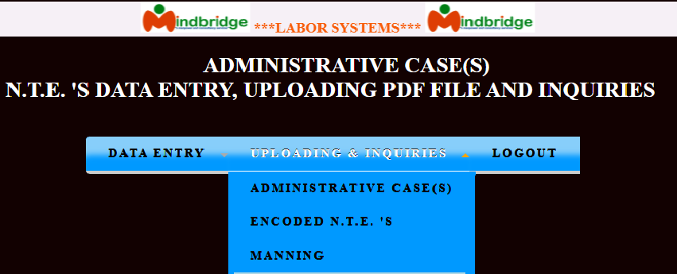

5.1 ADMINISTRATIVE CASE(S)

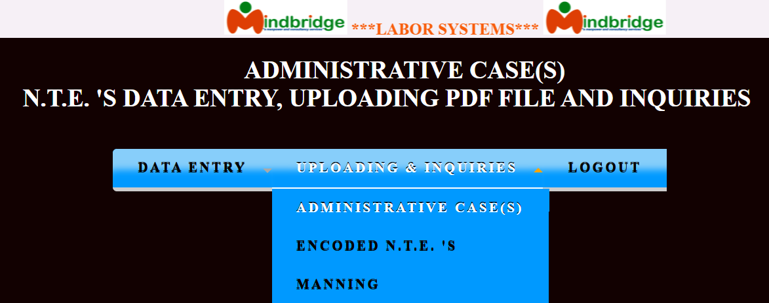
ADMINISTRATIVE CASE(S) - Allow the user(s) to inquire all administrative case(s) related.
1. Press the UPLOADING & INQUIRIES
=> ADMINISTRATIVE CASE(S)

On selecting the “ADMINISTRATIVE CASE(S)” option, the Information window is displayed. Given next window below is a sample display of the ADMINISTRATIVE CASE(S) control information window.
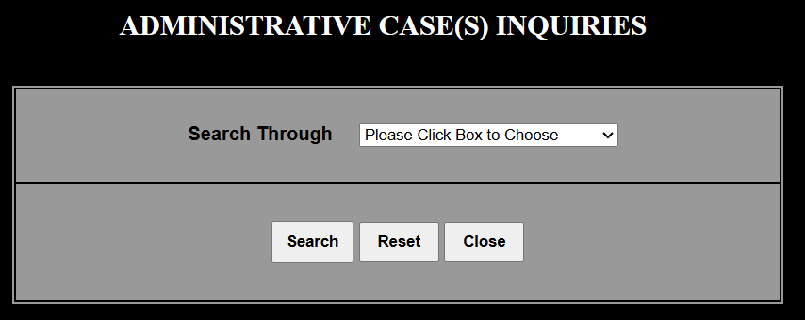
The Labor user(s) will press the drop down box to choose which Search through to use in uploading & inquiries. The LS user(s) had an option to use Search Through: BY PERSON INVOLVED or BY PLANT LOCATION. Given next window is a sample display control information window.

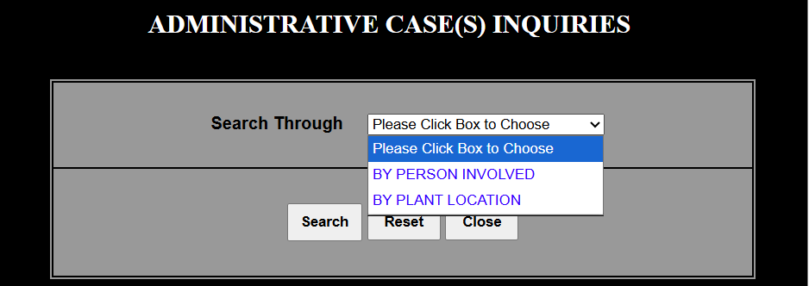

BY PERSON INVOLVED

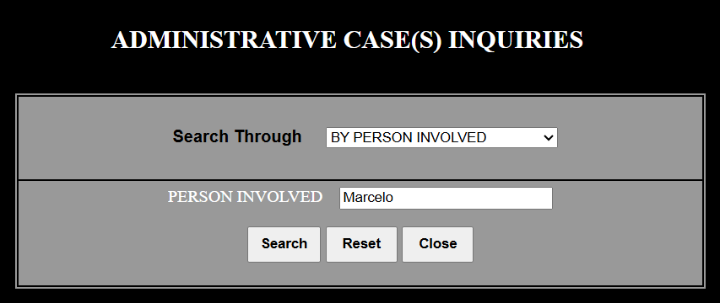

Where selecting a specific entity (BY PERSON INVOLVED) acts as a filter to instantly display all associated records in a secondary display area. Alternatively user(s) can input only the Firstname or Last name or FullName in the field to view the relevant file data. When you click the SEARCH button, the system typically opens a new, dedicated window or that displays comprehensive information.
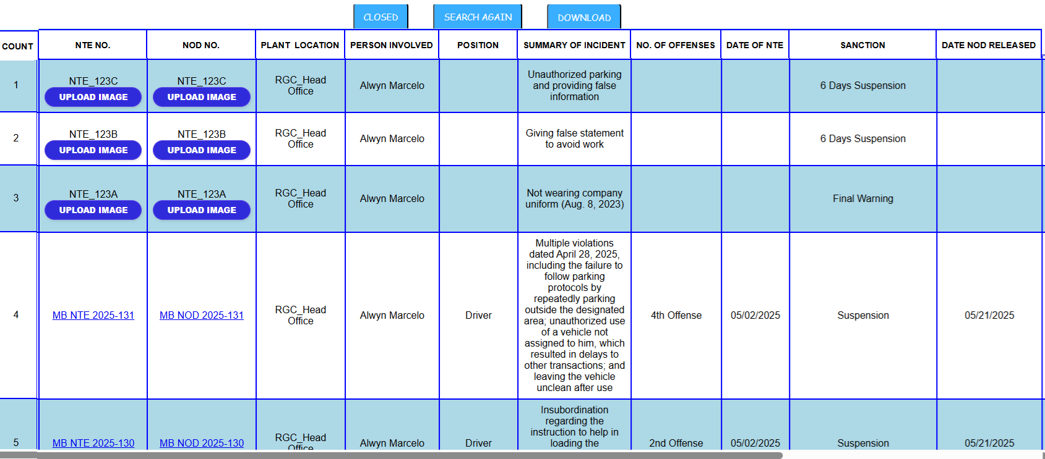
Example:

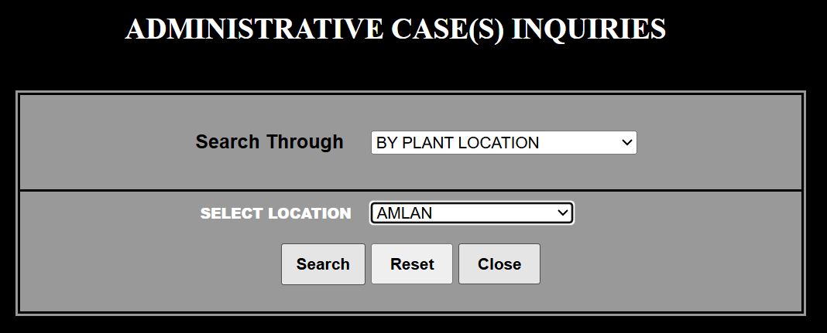
BY PLANT LOCATION

Plant location options are frequently filtered based on their user(s) assignment. Selecting a plant location, the dropdown list of values is typically populated by retrieving a predefined set of location data associated with a specific entity and to show only to the user(s) entries that are authorized for that plant location. Choose the desired location from the provided list, then click the button labeled "Search”. The filtered data, such as records, search results, will be displayed on the page.
Example Amlan:
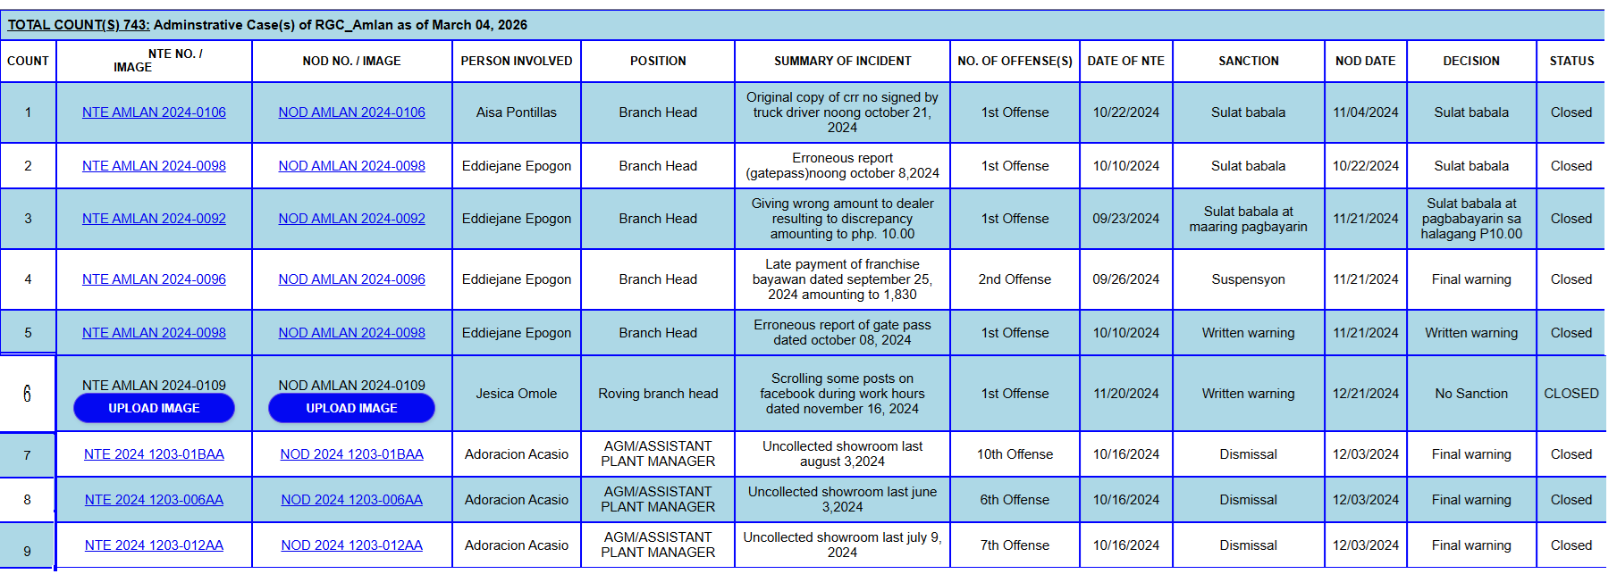
NOTE: If the interface displays a button or placeholder that says "UPLOAD IMAGE", it generally indicates that a file-including a PDF intended to be displayed as an image-has not yet been successfully uploaded or detected.

5.1.1 UPLOADING (N.T.E. & N.O.D.)
In this window, the user(s) are allowed to “UPLOAD IMAGE”.

In uploading NTE or NOD, Ensure the PDF image filename matches the actual NTE NO. or NOD NO.. The control number displayed on the screen may not be the actual, correct NTE/NOD number. If the displayed number is incorrect, click on the upload button to edit and input the correct, accurate NTE or NOD, as shown below;
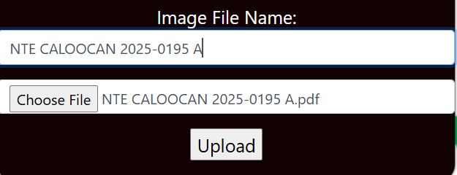
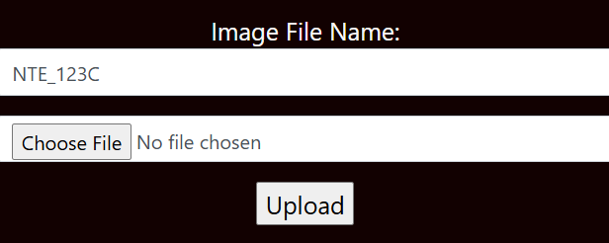

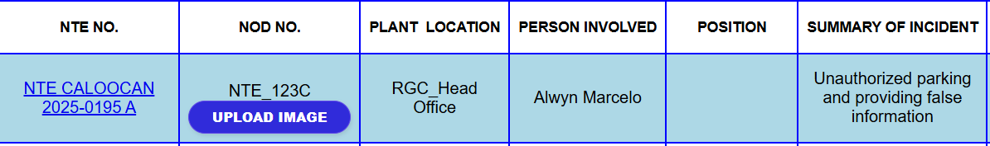
Upon clicking upload, the system usually attaches a Document into the corresponding control number as shown below;

5.2 ENCODED N.T.E.’S
1. Press the UPLOADING & INQUIRIES
=> ENCODED N.T.E.’S
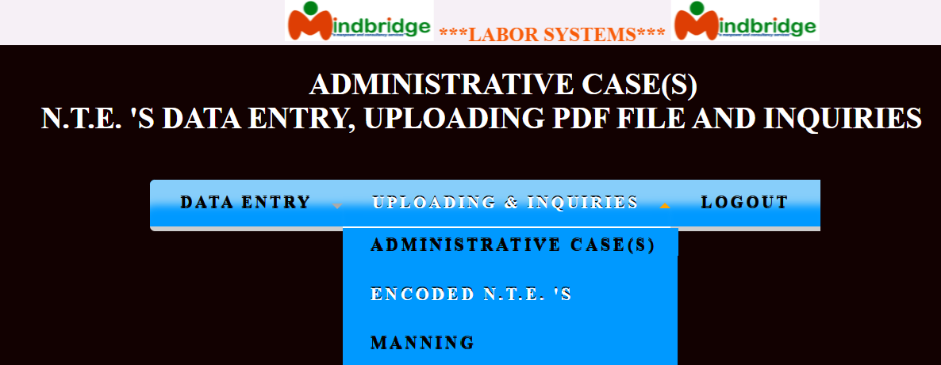
When selecting the ENCODED N.T.E.’S option, the displayed window typically summarizes previously generated or pending disciplinary notices. Depending on the user access location. Given next window below is a sample display of the ENCODED N.T.E.’S control information window.
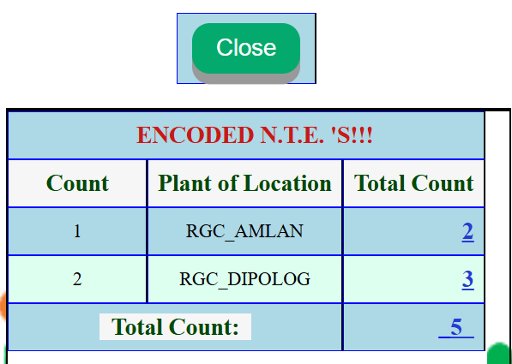

Clicking the total count display per location, allows user(s) to view, verify, and potentially manage the specific "ENCODED NTEs" for that location as shown next screen window;
This screen show has the option of the following listed below;
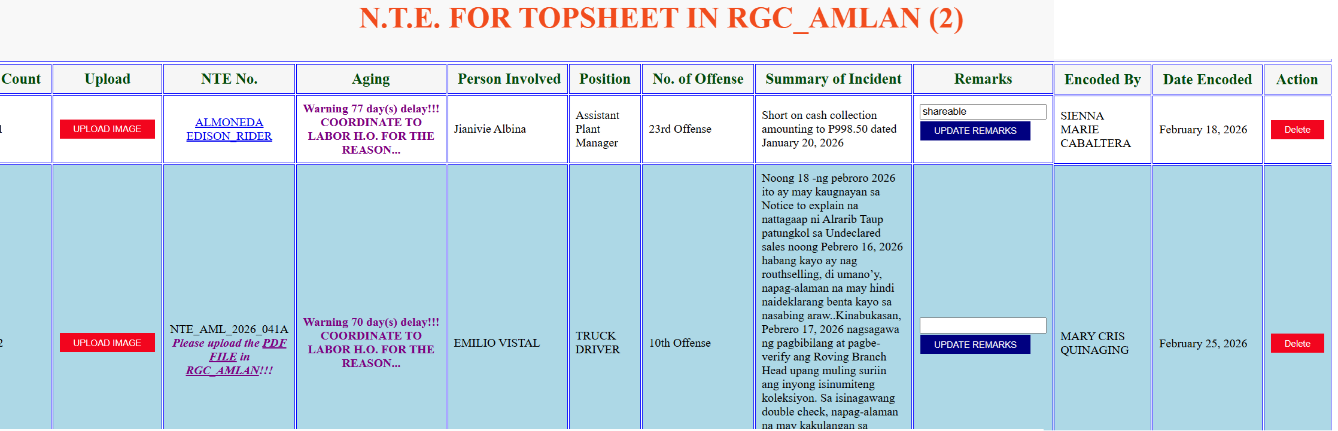

The user can Upload Image, Update Remarks & Delete.
- UPLOAD IMAGE = Allowing user(s) to upload, review, and re-upload PDF image files, especially when files are missing, illegible, or insufficient.
- UPDATE REMARKS = Applicable to shareable cases. In “Remarks” field, type the word “Share or Shareable”, if a case is classified as involving shareable charges , and it is assigned to a specific Labor Associate handling such cases, the entire case, including its documentation and resolution, will be managed by that designated personnel.
- Delete = Allowing authorized user(s) to delete cases specifically restricting them to deleting only cases they own or created is a best practice for maintaining data integrity and security.

5.3 MANNING
1. Press the UPLOADING & INQUIRIES
=> MANNING
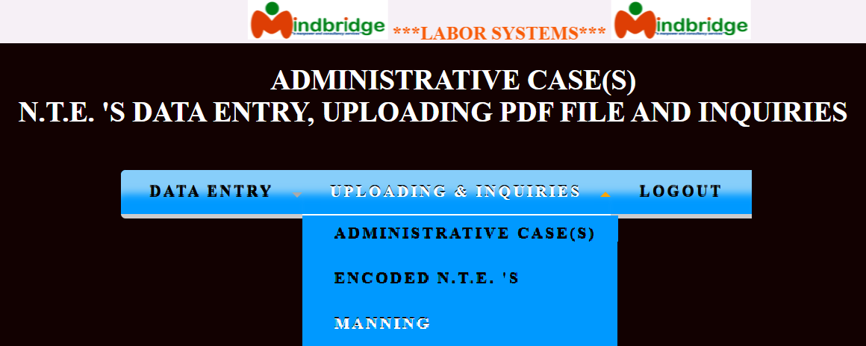

ADMINISTRATIVE CASE(S) - Allow the user(s) to inquire all administrative case(s) related.
1. Press the UPLOADING & INQUIRIES
=> MANNING

On selecting the “MANNING” option, the Information window is displayed. Given next window below is a sample display of the MANNING control information window.
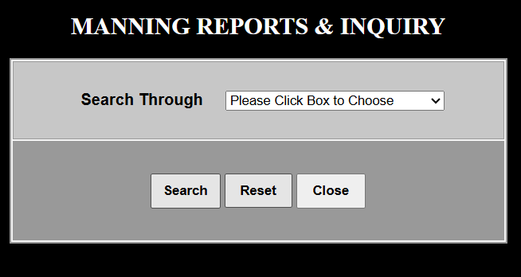

The user(s) will press the drop down box to choose which Search through to use in uploading & inquiries. The LS user(s) had an option to use Search Through: BY PLANT LOCATION or BY PERSON INVOLVED. Given next window is a sample display control information window.
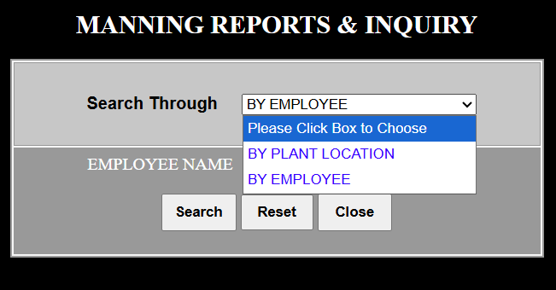

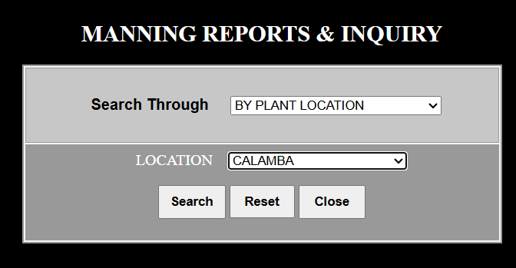
BY PLANT LOCATION

Plant location options are frequently filtered based on their user(s) assignment. Selecting a plant location, the drop-down list of values is typically populated by retrieving a predefined set of location data associated with a specific entity and to show only to the user(s) entries that are authorized for that plant location. Choose the desired location from the provided list, then click the button labeled "Search”. The filtered data, such as records, search results, will be displayed on the page.
Example CALAMBA:

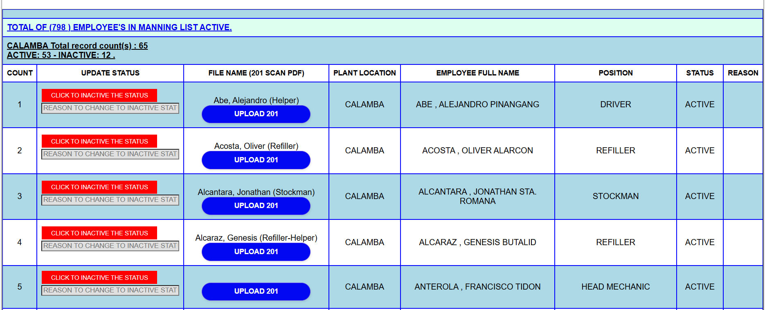
This module enables HR users to update an employee’s status to “INACTIVE” specifically for personnel who are no longer actively employed or connected to the company. This status is typically applied when an employee leaves the company (voluntary or involuntary resignation, termination, or retirement).

NOTE: If the interface displays a button or placeholder that says "UPLOAD 201", it generally indicates that a file-including a PDF intended to be displayed as an image-has not yet been successfully uploaded or detected.

5.2.1 UPLOADING (201 PDF FILE(S))
In this window, the user(s) are allowed to “UPLOAD 201 PDF FILE(S)”.

In uploading 201 PDF FILE(S), ensure the PDF image filename matches the actual 201 PDF FILE(S). The control number displayed on the screen may not be the actual, correct 201 PDF FILE(S). If the displayed FILE NAME (201 SCAN PDF) is incorrect, click on the upload button to edit and input the correct, accurate FILE NAME (201 SCAN PDF), as shown below;
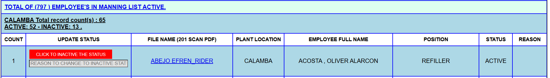
After uploading with correct file name:

Uses of fields:
- UPLOAD N.T.E. NO. - Uploading an PDF image means transferring a photo or picture file from a local device (like a computer, phone, or camera) to a remote server (Labor Systems), website, or storage system via the internet. This process makes the image accessible to others, allows for backup. Images can be uploaded via web browsers, apps, or directly from cameras using Bluetooth/Wi-Fi. It requires an active internet connection, and the speed depends on your network's upstream bandwidth, typically file format like PDF.
- N.T.E. NO. - The Notice to Explain (NTE) Number is a unique, alphanumeric identifier assigned to N.T.E. case(s). It functions as an internal tracking mechanism to monitor, file, and secure documentation of alleged employee misconduct.
- PERSON INVOLVED - Refers to an individual connected to, participating in, or affected by a specific situation, incident, or legal matter.
- POSITION - Position of the Person Involved.
- SUMMARY OF INCIDENT(S) - Provides a concise, factual overview of an unexpected event, covering who was involved, where and when it occurred, and the impact. Details of injuries sustained and damage to property or equipment.
- NO. OF OFFENSE - Refers to a count of individual criminal violations within reported incidents, which may differ from the total number of incidents.
- ARTICLE(S) - Specific sections detailing company policies, procedures, code of conduct, and employee benefits. They serve as a guide to workplace rules, legal compliance, and cultural expectations, helping to standardize management practices and communicate expectations to staff.
- PLANT LOCATION - It involves evaluating regions and specific sites or location based of the incidents.
- N.T.E. DATE - Refers to the specific date an employee formally submits their written explanation (reply) to a Notice to Explain (NTE) issued by their employer regarding alleged company policy violations.
- REMARKS - Generally refers to an additional comments, or opinions usually a passing observations.

Button(s):

Button | Description
 | Allows the user(s) to save the data made in the data entry.
 | Allows the user(s) to clear all data encoded without saving any changes
 | Allows the user(s) to close the module / pagewithout saving any changes.
 | Allows the user(s) to logout the module and returns to login page.
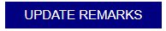 | Allow the user(s) to update the encoded REMARKS especially shareable
 | Allow the user(s) to upload image PDF file
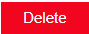 | Allow the user(s) to delete the record encoded N.T.E. case(s)
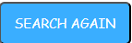 | Allow the user(s) to search another person involved



SYSTEMS DEVELOPER : CHERRY ESCLEO-CODILLA
POSITION : LABOR DATA ADMINISTRATOR

